PASSPORT MANAGEMENT SYSTEM:-

Class diagram-

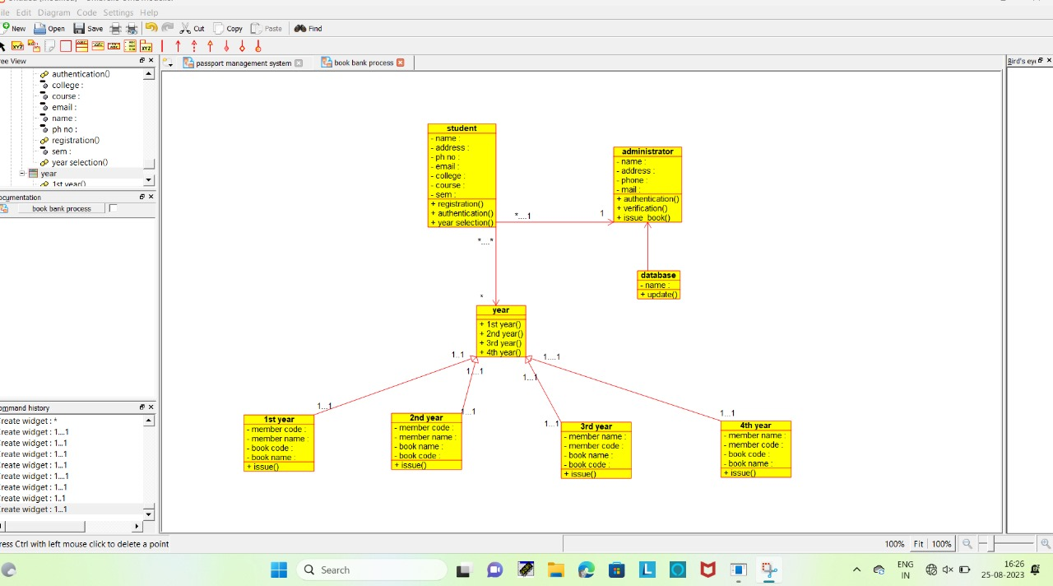

USE CASE DIAGRAM:-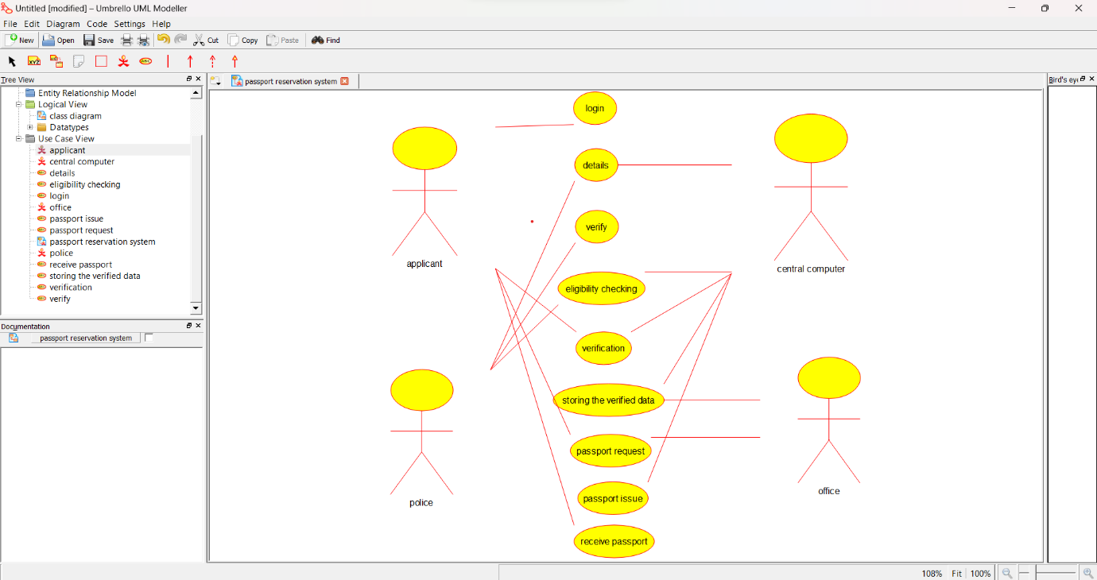

ACTIVITY DIAGRAM:-

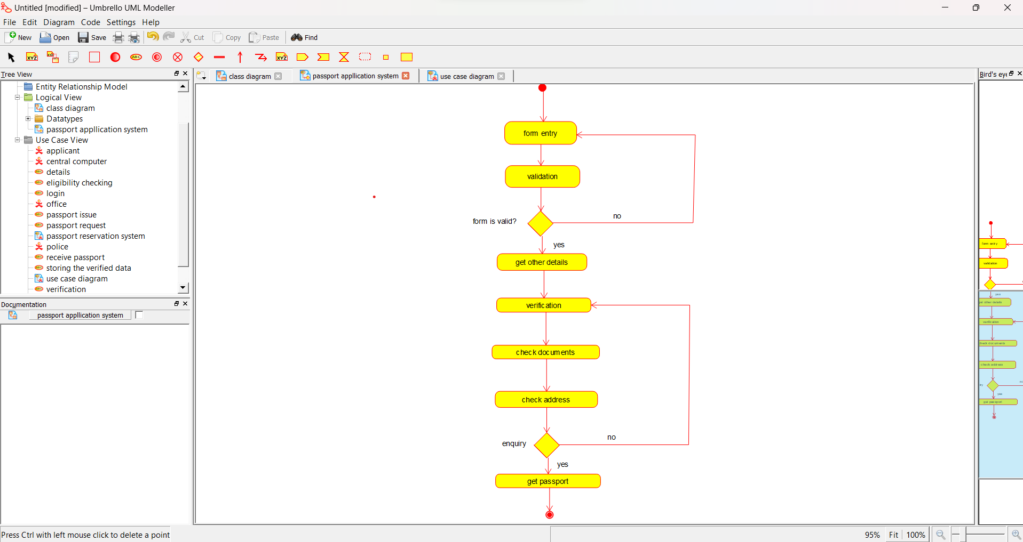

BANK BOOK PROCESS:-

(CLASS DIAGRAM):-

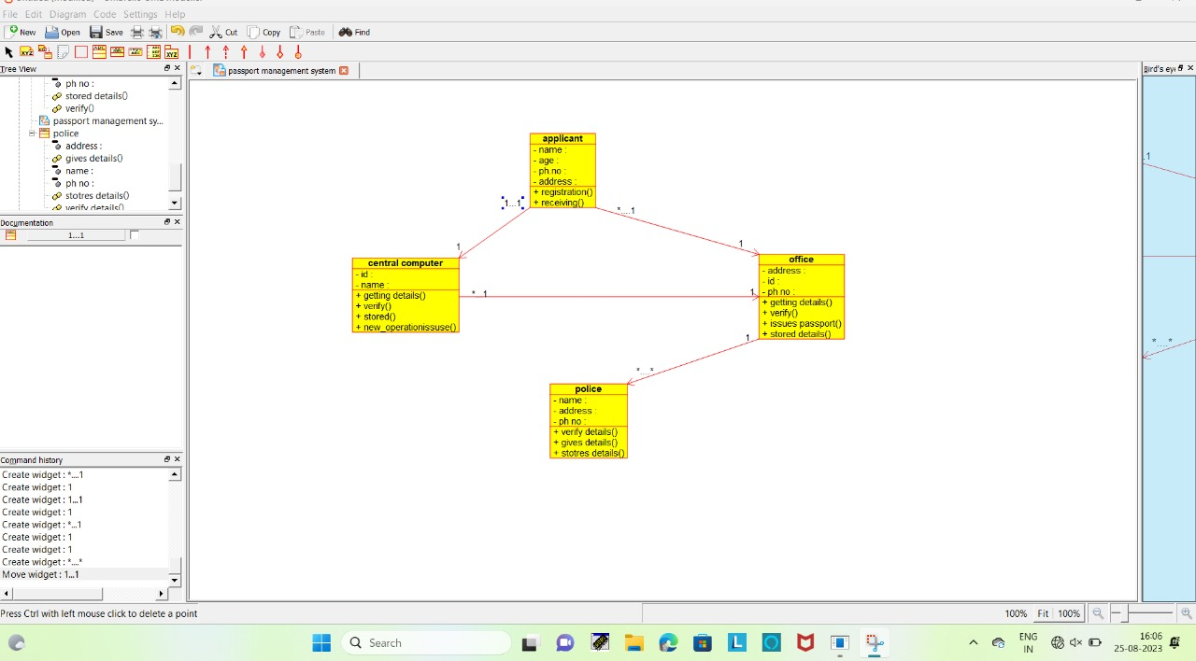

USE CASE DIAGRAM:-

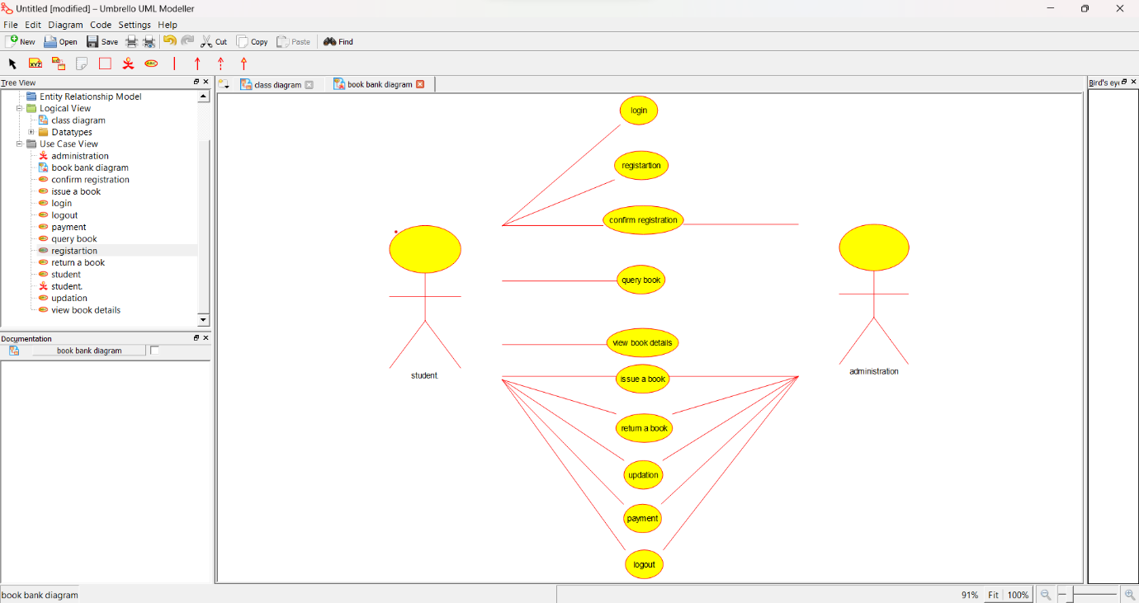

ACTIVITY DIAGRAM:-

